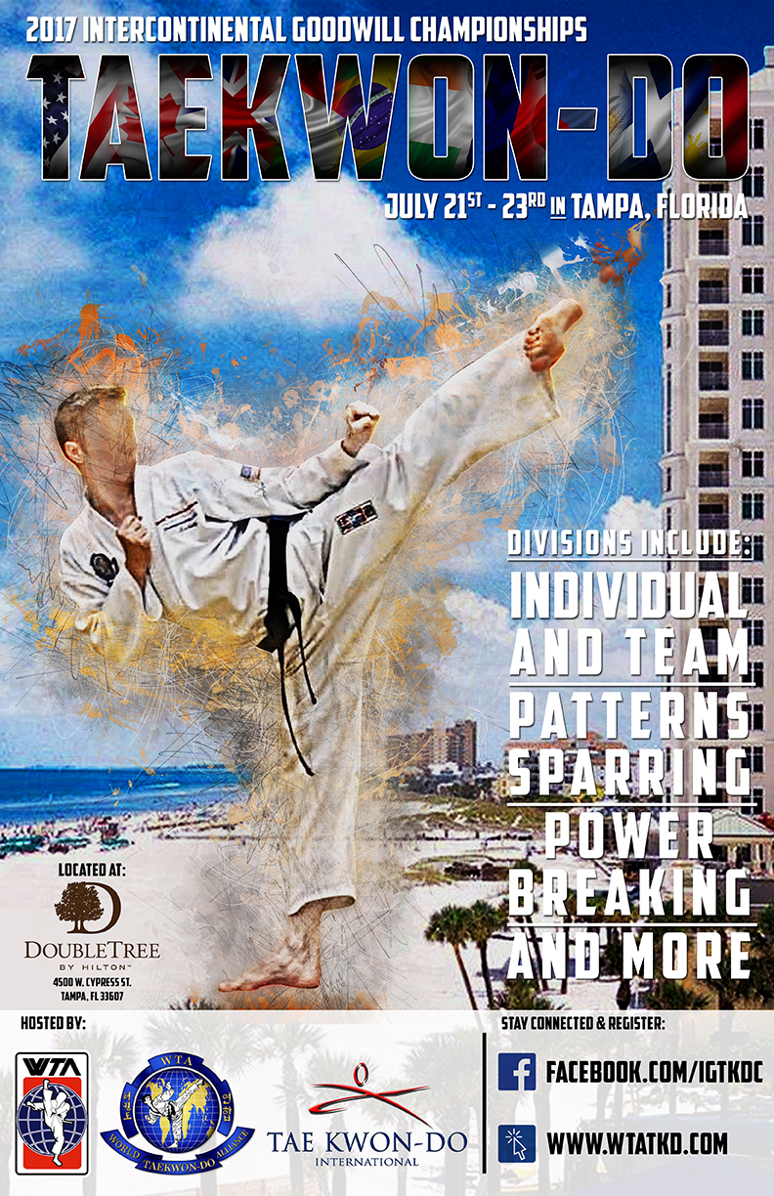

The 2017 Intercontinental Goodwill
Taekwon-Do Championships

RULE BOOK

Competition Rule Book-

General-

- Judges- All judges (umpires) hereinafter referred to, will be considered to have at least attended an umpires course.
  - All Judges will be wearing the designated Umpire shirts to be recognized accordingly or Do-Bok.
  - Each Competition will have a Senior or designated Head Umpire that will be responsible for starting, stopping and controlling the competition in accordance with the rules stated.
  - At least three (3-5) judges will be actively judging each event.
  - A Tournament Director will be assigned and any disputes or ruling questions should be addressed to the Tournament Director (Head Umpire).
- Competitors- Competitors will compete in the divisions as laid down
in the following rules.
  - They must also have filled in and signed the relevant form(s) for the competition in question.
  - Bandages and strapping. All competitors with injuries which require bandages or strapping of any type must satisfy the judges of their needs and obtain approval of the type of bandaging before performing (i.e. no hard materials or pins can be worn, neither can bandaging give extra support so that it constitutes an advantage to that competitor). Any doubts or questions of this rule will be decided upon the day of the competition by the Chief Referee.
  - Jewelry No jewelry, watches or any other adornments may be worn. Hair may be kept in place using material of a soft elastic nature only, no grips or slides are allowed.
  - Injury Liability. As stated in Rule 2. all competitors must sign a tournament entry form which contains words or wording exonerating the World Taekwon-Do Alliance, Taekwon-Do International, tournament organizers and all other competitors from any liability through injury sustained during the course of the tournament.
  - Official commands. The following are the only recognized commands that the referees and instructors will issue to competitors during the tournament.
1. Cha ryot - Attention
2. Kyong ye - Bow
3. Chun bi - Ready stance
4. Si jak - Start
5. Hye Chyo - Break
6. Barro - Return to ready stance

3. Dispute procedure. For all events in all tournaments, any disputes arising will be dealt with as follows:
a) Tournament Director will be appointed as the 'Tournament Chief Umpire'. This person must be present in the arena throughout the whole of the tournament. Generally this person will be the most experienced official present at the event. He or she will also appoint an Assistant Tournament Director if, for any reason the chief umpire is called away.
b) All competitors who wish to dispute a decision must do so through their instructor to the Head Umpire of a given Ring. Neither the competitor nor any other person other than the instructor is allowed to approach the Head Upire or chief umpire directly.
c) In order to give a final decision on any dispute, the chief umpire or his/her Assistant may call officials, competitors or instructors as he/she so desires in order to give evidence or opinions on the dispute. This strictly prohibits spectators.
d) On reaching a decision, the Tournament Director will notify all parties concerned. This decision will be binding and cannot be appealed against.
e) Instructors, competitors or team captains who persist in arguing against a decision made by the Tournament Director may, at his/her discretion, have their whole team or club disqualified from further events in the tournament.

PATTERNS
General
- Awards. Awards will be given at the official Awards Podium. Competitors will be notified of the final results at the ring of competition. They will then proceed to the Awards Podium for presentation and photos.
  - 1st place award.
  - 2nd place award.
  - 3rd place award.
- Judges, Officials and Performance Area Officials. Three or five judges, (at the discretion of the Tournament Director), including a senior official (seated on the perimeter in a line facing the start position) Note: The senior official will sit in the center of the judges One instructor (standing to issue commands) Two recorders (seated on the perimeter facing judges)
- Rings. Ring areas should ideally be between 7 x 7 and 9 x 9 meters, as in sparring but with an inverted white “T” marked in the center. (Start position) Contestants are expected to stand with their heels on the exact center of the “T” until the order “junbi” is given.
- Scoring Procedures. Each judge will deduct 0.1 from the final score for each of the following:
a) Omission of one or more steps or moves (3 or more steps or move will result in disqualification as this would constitute an incomplete pattern).
b) Failure to complete the pattern in a continuous performance (i.e. hesitation or loss of balance, a hesitation of longer than 3 seconds will be considered failure to complete the pattern and therefore also warrant disqualification).
c) Incorrect technique e.g. A forearm block instead of a knife-hand block. A high kick instead of a middle kick, etc
d) An incorrect ready position. Note: The above are only a few examples of incorrect techniques.
e) Incorrect diagram. This incorporates not finishing on the “T” as the diagram would obviously be incorrect. If a competitor fails to complete the pattern, they will be brought back to ready stance and dismissed. No score will be shown by the judges.
5. Method of Scoring. Each judge will record their score on the score cards, on
the command “show” given by the senior judge sitting in the center of
the judges. They will immediately hold up the score cards and keep
them in that position until the recorder acknowledges that all scores
have been recorded. The red score card will be held in the right hand
and the blue card held in the left hand. The recorder will then record all the scores of three or five judges, then deduct the highest and lowest scores (only if there are five) given by the judges and total up the remaining scores. This total is recorded as the competitors score.

In the event of a tie between two or more individual pattern competitors, the senior judge or chief referee may, if he/she wishes, select a pattern to be performed by those competitors only, or a choice pattern may be allowed.

Note: In the colored belt patterns, a competitor who has a clear winning score does not have to go into a second round unless two different sets of three judges are used. The same applies if there is a clear first and second place. Only competitors with equal scores need to go on to a further round.
In Black Belt patterns, the highest scoring individuals (up to a maximum of 8 competitors) will go through to a second round where they may perform a pattern selected from their particular grade. If it is considered by the chief umpire that the first rounds scoring has shown a clear trophy winning group, he or she may decide a second round is not necessary. This will be decided upon the day of by the Tournament Director.

Recording Scores (score card photos required)

Pattern name and scores are entered onto the score sheet against the competitor’s name (score card photos required)

The highest and lowest scores are ignored (score card photos required)

The remaining scores are added together to give the overall pattern score

- Patterns. Men, Women, Boys and Girls will compete in separate divisions.
Black Belts will compete in one or two groups depending on numbers participating. Color Belts will perform in their respective belt color divisions:
White/Yellow: Chun-Ji, Dan-Gun, Do-San.
Green/Blue Belts: Won-Hyo, Yul-Gok, Chun-Gun.
Red/Brown Belts: Toi-Gye, Hwa-Rwang, Choong-Moo.
BLACK BELTS MUST ONLY PERFORM PATTERNS WITHIN THEIR RANK STATUS.
1st/2nd Degrees: Gwen-Gae, Po-Eun, Gae-Baek, Eui-Am, Jhoong-Jang, Ko-Dang.
3rd Degrees: Sam-Il, Yoo-Sin, Choi-Young.
4th Degrees & above: Yon-Gae, Ul-Ji, Moon-Moo.So-San, Se-Jong, Tong-Il.

Each competitor will perform a choice or compulsory pattern chosen by the organizers prior to the event. The Patterns will be marked in 1/10 of a point divisions, as laid down in the following scales:

Poor standard 6.0
Below average standard 7.0
Average standard 8.0
Above Average standard 9.0
Excellent standard 10.0

SPARRING

1.Awards. Awards will be given at the official Awards Podium. Competitors will be notified of the final results at the ring of competition. They will then proceed to the Awards Podium for presentation and photos.
  - 1st place award.
  - 2nd place award.
  - 3rd place award.

2. Area -The sparring area should ideally be between 7 and 9 meters squared with the perimeter clearly defined by colored tape stuck to the floor. There will also be two starting marks approximately 2 meters apart, positioned centrally in the area.

3.Officials –
CONTINUOUS SPARRING – 2 or 4 Corner Judges (seated outside the sparring area, one on each corner) 1 Referee (standing in the center with the fighters) 1 Timekeeper (seated at the table on the edge of the sparring area) 1 Recorder (seated next to the timekeeper).

POINT STOP SPARRING 1 Referee (standing) 2 Roving Judges (standing opposite) Timekeeper (seated at the table) 1 Recorder (seated at the table)

- Sparring Equipment. All sparring equipment must be of a type that has been approved by the WTA & Taekwon-Do International. It's condition must satisfy the chief referee’s concern for effectiveness of safety. Equipment which is damaged or has been excessively taped for repair will not be allowed. If the referee is not completely satisfied with the state or type of equipment being used by any competitor, he must immediately alert the competitor who is given a two-minute warning to replace and/or borrow acceptable gear.
All competitors must wear the following equipment:
1. Head guard (of an approved type)
2. Hand sparring equipment (of an approved type)
3. Foot sparring equipment (of an approved type)
4. Shin and instep pads (of an approved type)
5. Groin guards MALE ONLY (of an approved type)
6. Mouth Pieces (of an approved type)
Optional equipment for female competitors are breast guards. Also considered optional is approved-body armor.

4. POINT-Bout Procedure and Timing. The bout will commence with the competitors on their respective start positions with either a red or blue waist band or marker. At the direction of the referee, the competitors bow to the referee, and then to each other. The referee will then start the sparring with the command “si jak”, at this point the clock will start. The competitors continue to spar until the referee issues the command “hye-chyo”, which he or she will do in order to issue an infringement. The clock does not stop at this point unless the referee gives the time out signal to deal with an injury or any other reason at their discretion. The bout will be re-started by the referee at the original start positions. On completion of the allocated time, the timekeeper will sound a bell/horn etc. in order to warn the referee that due time has been reached. But the bout only ends on the final command “hye chyo” by the referee.

5. Duration of Bouts. Each bout will be 2 minutes continuous duration, or two -2 minute rounds of continuous duration with a break of 60 seconds time in between rounds.

6.Draws -In CONTINUOUS SPARRING, if a draw is given after time has been called, a further extension will follow. The time extension will be 50% of the original bout time. If a result is not achieved after one such extension, the referee will inform the judges that, if their clickers are showing a draw after the second extension, they must make a decision on technical merit.
7.Draws-In POINT STOP SPARRING, if a draw is given after time has been called then the “SUDDEN DEATH RULE will apply. This means that the first person to score will be the winner.

8.Scoring and result procedure CONTINUOUS. The corner judges will award points as they are seen by using hand held recorders (clickers). These should be clearly marked left hand clicker blue, right hand clicker red. On completion of the bout and after bowing procedure, the referee will call “show”, at which the corner judges will immediately hold in the air the clicker showing the highest score. In the event of a draw, both clickers are held up with the arms crossed. At this point, the referee himself will make a decision and then award the bout as either a win or draw. A win can only be awarded if 3 or more of the 5 judges, or 2 or more of the 3 judges award the bout one way. Any less is awarded as a draw.

9.POINT STOP. The referee will stop the bout with the command 'hye chyo' if any judge indicates a clean technique has been scored. The other judges must immediately issue a signal (No See/ No Score / Score) If any two from either the two (2) Roving Judges, or Umpire agree that a technique has been scored, an appropriate amount of points will be awarded by the referee. Two out of the three officials must agree on the points scored for it to be registered. The only exception to this rule will be the ability of the referee to override the two officials if he/she has definitely seen a score and the two officials are showing unsighted techniques. These points will be displayed by the recorder on either blue or red score cards and these cards will be situated at the recorder's table for all to see. The red card will be on the right of the table and the blue card will be on the left hand side. (the left and right being determined by the score keeper as he/she sits at the table). The officials should try to make their decisions as quickly as possible so that the bout continues at a reasonable pace. Any demerit points will be added onto the opponents score. If a competitor scores a 10 point lead, then the bout will be stopped and awarded to that competitor.

10.Recording Results. The sparring results sheet will contain the event date and title, the entry category, the number of pools, entries in that pool and total number of entries in the category. Referee and umpires should check the presence of all competitors on the listing prior to commencing the bouts. Competitors with BYE’s will be automatically entered into the next round
(photo of bracket sheet in posted here)

Winning competitor’s names are entered into the next round boxes. In the semi-finals and finals the competitors club is also collected. Any official warning and / or disqualifications are noted on the results sheet also.

Referees are responsible for ensuring these results sheets are correct.

11.Target Area.
(a) Head and neck area complete. (Excluding the throat)
b) Trunk of the body from the neck to lower abdomen vertically and from an imaginary line drawn from the armpit vertically down to the waist on each side (i.e. frontal area and side area of the body only, excluding back).
12. Points. Points are awarded as follows:
a) 1 point awarded for any hand technique to any target area.
b) 2 points awarded for foot technique to mid-section area.
c) 2 points awarded for a jumping reverse punch (black belts only)
c) 3 points awarded for foot technique to high-section area.
13. Point scoring awards. Points will be awarded for a scoring technique only. This consists of:
a) Attacking tool making touch contact but with control so as not to cause injury nor be likely to cause injury to the opponent.
b) Appropriate attacking tool should be used correctly and in a forceful manner with speed and accuracy. Touch contact is defined as 'the safety equipment making contact with the target area without any further force being applied. The force of the attack should cease at the moment of contact so that no pressure other than that of touch is felt by the opponent.
14. Demerit points and disqualifications. 1 point will be deducted the player that received the infraction. If this player has no score, the referee will award his/her opponent one (1) point.
15. MINUS POINT - CONTINUOUS ONLY
a) Stepping out of the area twice (i.e. on the 2 , 4 , 6 and every other subsequent occasion). A competitor is considered to have stepped out when one foot fully crosses the perimeter line. Deliberate exits to avoid sparring will result in minus 1 point on every occasion, this would constitute bad sportsmanship.
b) Loss of balance on each occasion (a competitor is considered to have lost balance when any part of their body other than the feet, come in contact with the floor The exception to this is if the referee considers that the loss of balance is due to a trip, push, illegal technique or a spilled substance on the floor of the fighting area.

16. MINUS POINT CONTINUOUS AND POINT STOP
a) Excessive contact (i.e. low kicking or swinging), but only at the referee's discretion.
b) Grabbing any part of the opponent or their do-bok at the referee's discretion
c) Tripping or leg sweeping the opponent on every occasion.

Discretionary 'points away' and 'official warnings' may be awarded by the referee for the following:
a) Talking in the ring.
b) Unsportsmanlike behavior.
c) Intentional lack of effort.
d) Excessive contact and /or aggression.

Disqualification will be awarded by the referee, after consultation with his corner judges for the following.
a) Intentional contact or unnecessary aggression.
b) Repeated 1 'point away' offense.
c) Showing dishonor or disrespect to the officials, competitors or area.
d) On the second occasion that an official warning is awarded (i.e. a red card is shown after the showing of a yellow card).
Note: The referee may, at his/her discretion, after consultation with the judges, disqualify a competitor without using a yellow card first, depending on the severity of the offense.

17. Disqualification due to Contact and Injury. Excessive contact is penalized at the referee's discretion. During a sparring competition, a referee may give an official warning for offenses under the previous section headed 'Demerit points and disqualifications'. Any competitor who receives one official warning during the entire competition will be disqualified from all the remaining competitions that day immediately upon receipt of the second official warning. The referee will announce to the competitor, corner judges and recorder that an official warning is being given. The recorder marks the official warning against the competitor’s name on the competitor's list and/or competitor card. Then, before the start of the next and all subsequent bouts, the recorder will announce that the competitor has an official warning. All competitors must have their Competition Card with them at all times during the competition.

18. Weight Divisions. All height & weight divisions will be sent out in the information pack prior to the competition All competitors must be a competent standard which should be assessed by their instructor who will sign their form to state the fact.

19. POWER BREAKING – Power Breaking will be offered for Male and Female separately. The contest will consist of a single blow with any given kick that the competitor would like to execute. Each division will be divided into various weight groups and the winner will be determined by a weight to power ratio. Ex. If two (2) competitors break the same amount the winner will be the player that weights the least.
1st Place award positions only.

20. The Ultimate Striking Challenge.

The Ultimate Striking Challenge consist of the total power generated by striking a foam block that is digitally measured by a computer with the results show on a large monitor. The contestant will strike three (3) times with any choice technique from their left side and any three (3) strikes from their right side. The computer will give the accumulated total of the six (6) strikes declaring the winner. In the event of a tie the contestant that weights the least will be declared the winner based on this power to weight ratio.

21. Team 3 Tag Team Sparring Stop and Go Point System.
Will consist of a 3-person team within the designated age and rank divisions. All three (3) players must spar. A player may step out immediately after a score or judge stoppage and tag a different team player to take their place. The total score after three (3) minutes will be declared the winner. In the event of a tie a pre-designated player will be selected to spar for a first point win final match. The same scoring and warning rules apply as in individual point sparring competition.

21. Team 3 Precision Patterns-
Will consist of a 3-person team within the designated age and rank divisions. Team’s will be graded on the same elements as individuals but include the Synchronization, Timing, Creativity, Technical Execution and overall performance. Colored belt teams must perform a colored belt pattern and Black Belts may perform any pattern within their most senior ranking player down. Teams may consist of all male, all female or any coed combination.

TEAM 5 COMPETITION. National Team tournaments consist of a 5 Man Continuous Sparring Team.

1.Awards. Award’s for team tournaments will be given as follows:
- 1st place medal/trophy per man plus optional team trophy
- 2ne place - 1 medal/trophy per man

2. Team Sparring. These will consist of teams that have between 5 competitors. A toss of a coin will decide which team sends out the first competitor regardless of whether the competition is to include sparring weights, patterns and breaking or not. The opposing team then has 30 seconds to have its competitor on the square. Sparring will be in divisions set out in the information pack prior to the event. If weight divisions are set out, then the competitor who is chosen to fight must be matched by the opposing team in weight. This is regardless of whether it be the heaviest, lightest or any weight in between. All competitors may, if they wish, spar at a higher weight but not a lower one. All competitors must be padded up and ready to go on to the fighting area within 30 seconds of their bout being called. The referee may award official warnings or points away to any competitor who fails to meet the 30 second deadline. If after the sparring match there is still a tie, then the referee, after consultation with the judges may choose a winner on technical merit as per individual sparring.

- Team 5 Patterns.
Team patterns will be judged as a separate event for the 2017 Intercontinental Goodwill Championships. This event will consist of Men’s or Women’s 5 Person Synchronized pattern performance. Team’s will be graded on the same elements as individuals but include the Synchronization, Timing, Creativity, Technical Execution and overall performance

